 | Writing Anchor Standards | Strategy
1. | Write arguments to support claims in an analysis of substantive topics or texts using valid reasoning and relevant and sufficient evidence. | Arguments= Many ideas for argument writing on pintrest boards http://www.pinterest.com/pin/212443307396547862/ or http://www.pinterest.com/elaseminars/writing-argument/
2. | Write informative/explanatory texts to examine and convey complex ideas and information clearly and accurately through the effective selection, organization, and analysis of content. | analysis of content= Highlighting Strategy  http://gse.buffalo.edu/org/writingstrategies/3-6highlighting.htm  informative/explanatory texts = pages 145 – 149 http://www.edu.gov.on.ca/eng/studentsuccess/thinkliteracy/files/writing.pdf
3. | Write narratives to develop real or imagined experiences or events using effective technique, well-chosen details and well-structured event sequences. | Narratives= Journals http://literacy.kent.edu/eureka/strategies/types_of_journals.pdf  Narratives= Unsent Letters Activity http://literacy.kent.edu/eureka/strategies/unsent_letters09.pdf
4. | Produce clear and coherent writing in which the development, organization, and style are appropriate to task, purpose, and audience. | Development= The Boxing Match writing development sheet  task, purpose, and audience= RAFT Strategy http://literacy.kent.edu/eureka/strategies/raft.pdf
5. | Develop and strengthen writing as needed by planning, revising, editing, rewriting, or trying a new approach. | Planning= “4 Paragraphs to Passing” http://gse.buffalo.edu/org/writingstrategies/pdffiles/ambrose.pdf  trying a new approach= The You Speak/ I Write Strategy http://gse.buffalo.edu/org/writingstrategies/6-12youspeakIwrite.htm  revising= CD Strategy http://gse.buffalo.edu/org/writingstrategies/6-12enhancingdetails.htm or Asking Questions to Revise Guide Sheet or Editing and Revising; Peer Editing
6. | Use technology, including the Internet, to produce and publish writing and to interact and collaborate with others. | to produce and publish writing= Publishing Toolkit http://gse.buffalo.edu/org/writingstrategies/Toolbox/Publishing_Toolkit.htm
7. | Conduct short as well as more sustained research projects based on focused questions, demonstrating understanding of the subject under investigation. | based on focused questions= Q20 Strategy http://gse.buffalo.edu/org/writingstrategies/6-12questionstooutline.htm  demonstrating understanding:= LINK Worksheet http://www.sccresa.org/downloads/common_core/link_20110329_115618_71.pdf
8. | Gather relevant information from multiple print and digital sources, assess the credibility and accuracy of each source, and integrate the information while avoiding plagiarism. | Gather relevant information= Column Notes (below)  avoiding plagiarism= Citation Guide http://library.csun.edu/Guides/ResearchStrategies/CitationStyleGuides
9. | Draw evidence from literary or informational texts to support analysis, reflection, and research. | Draw evidence= CEE Pyramid (below)
10. | Write routinely over extended time frames (time for research, reflection, and revision) and shorter time frames (a single sitting or a day or two) for a range of tasks, purposes, and audiences.
11. | Develop personal, cultural, textual, and thematic connection within and across genres as they respond to texts through written, digital, and oral presentation, employing a variety of media and genres.

The basics of TEACHING WRITING STRATEGIES::
http://gse.buffalo.edu/org/writingstrategies/steps.htm
A Writer’s Toolkit for all steps of writing: http://gse.buffalo.edu/org/writingstrategies/Toolbox/index.html
The Writing Workshop included Resources: http://gse.buffalo.edu/org/writingstrategies/WritingWorkshop.htm
Additional support Guide with Student sheets and teacher instructions; http://www.edu.gov.on.ca/eng/studentsuccess/thinkliteracy/files/writing.pdf
Writing Process: http://literacy.kent.edu/eureka/strategies/help_writing_process.pdf

Boxing Match; Writing Development Worksheet
BEFORE THE FIGHT
- Pre-match strategy
  - Carefully read the Overview, Situation, Task and Guidelines.
  - In the Situation, highlight the key words that tell you what content you much include in the essay.

- List, here, the key words of phrases you have highlighted: (number may vary)

  - _________________________

  - _________________________

  - _________________________

  - _________________________

- Enter the key words in the spaces at the top of each box.
- After reading the first piece given, enter appropriate information from the piece into the box where it will be a supporting detail.
- After reading the second piece given, enter the appropriate information from the piece into the box where it will be supporting detail.
- Repeat if there are more than two pieces.
Now, you are prepared to fight the good fight! Use what you have learned about BOXING to help you win!
SAMPLE:
Connect key word or phrase from piece #2
- Supportive detail or explanation from piece #2
- Supportive detail or explanation from piece #2
- Personal comment of details or explanation

Connect key word or phrase from piece #1
- Supportive detail or explanation from piece #1
- Supportive detail or explanation from piece #1
- Personal comment of details or explanation

Boxing Match

First Piece

Second Piece

Column Notes
Topic from the text | What you learned from  reading the text | Opinions, observations,  thoughts regarding the topic

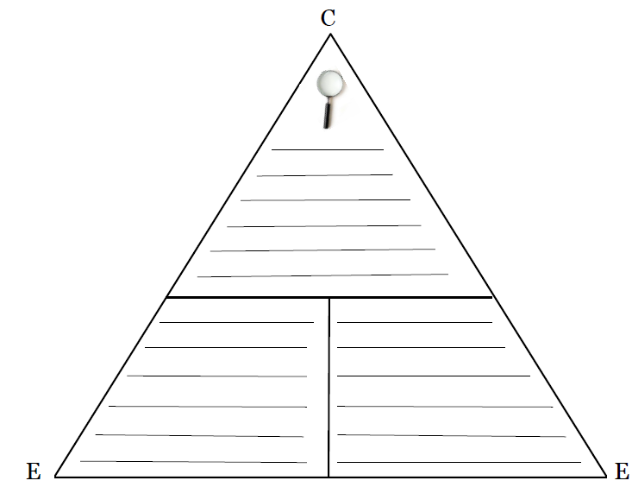
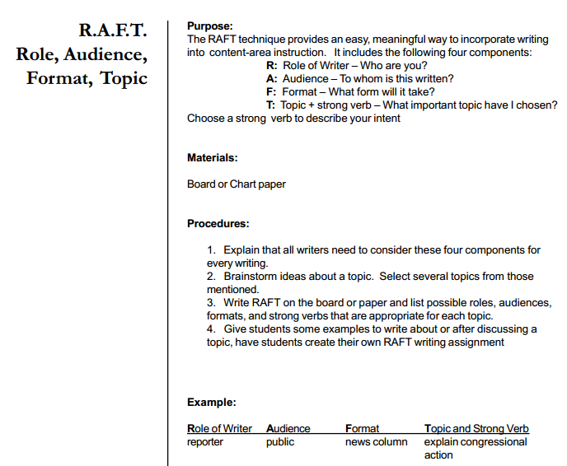
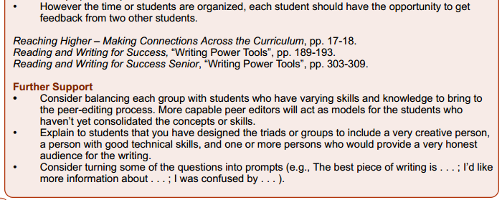
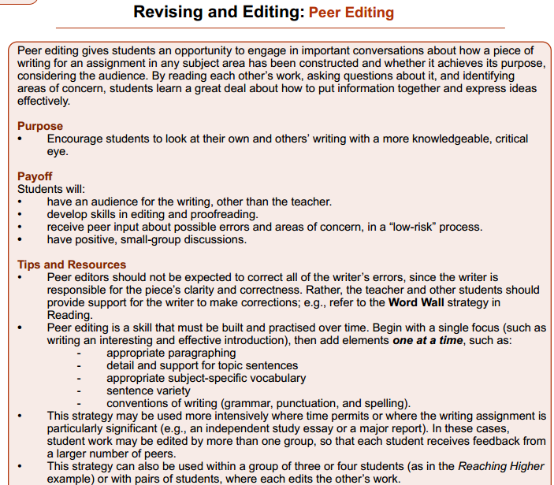

http://www.edu.gov.on.ca/eng/studentsuccess/thinkliteracy/files/writing.pdf

