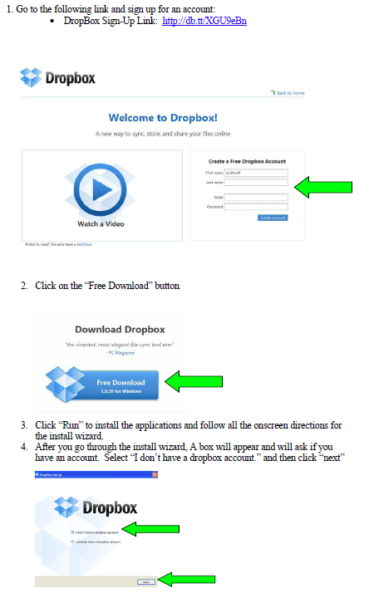
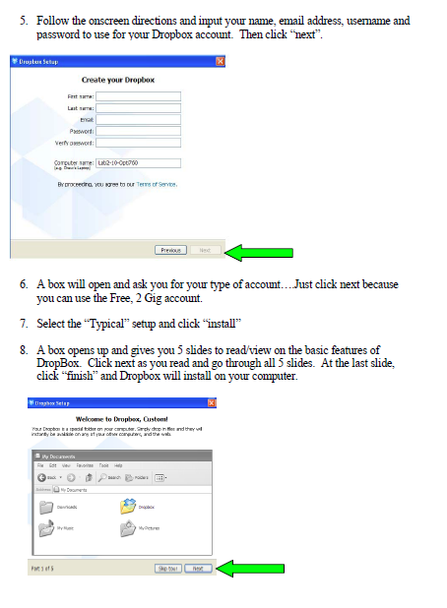

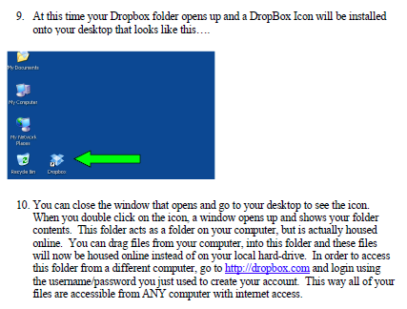

Adding: www.DropItTo.Me
- Go to www.dropbox.com and login to your account. Leave this account open in a browser.
- Go to www.dropitto.me and click on “register”
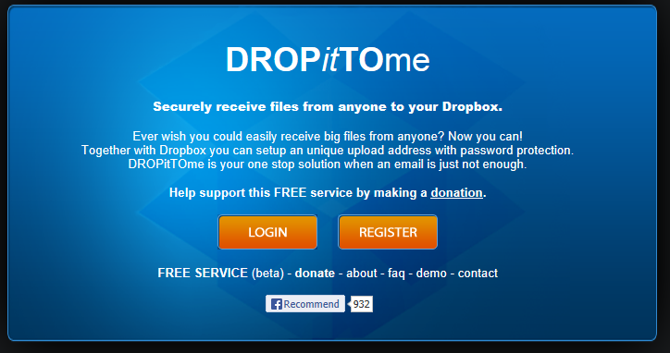

- Drop it to me will ask you to either open your dropbox account or to allow access your dropbox account….select allow. This links your drop it to me account to your dropbox account.
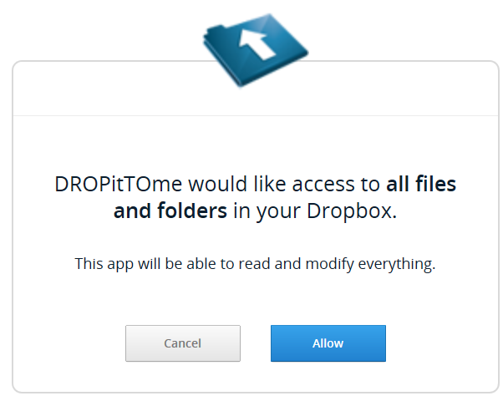
Once you allow, it will ask you for a username, password and upload password. PLEASE BE AWARE of a couple of things….
- Your username becomes part of your address for people to upload documents to….
  - My username is “SChristopher” therefore my address to upload to is “www.dropitto.me/schristopher”
- Your password and upload password must be different. The upload password you will give out and will allow others to upload documents to your account.

4. Once you register for your dropitto.me account, you will find a new folder in your dropbox. This folder will be the location where all uploaded files from dropitto.me will be directed to.

