Walk Around Survey: Right Triangle Trigonometry

Question: | The value of $x=$ | The value of $y=$ | The value of $z=$
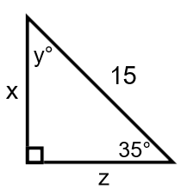 | Name_________ | Name_________ | Name_________
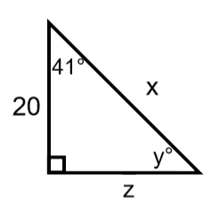 | Name_________ | Name_________ | Name_________
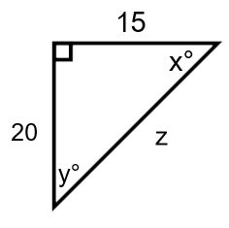 | Name_________ | Name_________ | Name_________

